Professor Robert Vichnevetsky 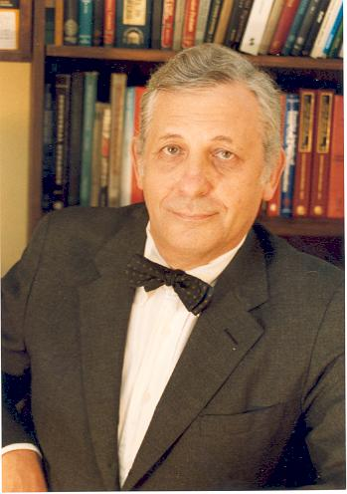

Robert Vichnevetsky has been President of IMACS since the 1970's, bringing this Association from a modest past (the predecessor of IMACS was AICA, the International Association for Analogue Computation, founded in 1956) to become a leading organization in the international network of scientific societies concerned with computation and applied mathematics. He is Professor of Computer Science with a joint appointment in Mechanical and Aerospace Engineering at Rutgers University. He has been an important contributor to the fields of applied mathematics and scientific computation, areas in which he has written several books, edited many more, and published in excess of a hundred research papers. He has lectured on these subjects in almost every country of Western Europe, in Japan, in Australia as well as at the USSR Academy of Sciences in Moscow and at the University of Brazilia.
He was born and educated in Belgium, graduating from the Free University of Brussels with the degrees of Doctor of Science in Mathematics and of Mechanical and Electrical Engineer from the University's Polytechnic School. He had prior to his present academic appointment a significant industrial career --- starting in 1957 as a member of EAI's European Computation Center in Brussels. The Center was equipped at the time with what amounted to the most powerful machines for computer simulation in Europe, serving industry by applying them to such things as the design of airplanes, chemical processes, nuclear power plants, automobile suspensions and the like. Vichnevetsky was Director of the Center from 1959 to 1963, later becoming Director of Research of the company in Princeton. EAI (Electronic Associates Inc.) had in the late 1950s and early 1960s been the leading company in the manufacturing of analog computers, playing a major role in the introduction of electronic computing in the western world, including an important place in the development of the US Space Program. One of Vichnevetsky's accomplishments during that period was in directing the team that designed the Analog Hybrid computer EAI680, at the time one of the most successful computers used for the simulation of dynamical systems: part of an EAI680 is displayed at the British Science Museum in London, having been relegated to its proper place in history.
He has also served as President of FIACC, the Five International Associations Coordinating Committee, a committee formed in the 1970's under the sponsorship of UNESCO to coordinate the activity of major professional international associations in those areas arising from the application of electronic computers and information processing technologies to the applied sciences.

