N8N8 end of civilized life
TODAY’S WORLD

In a few centuries from now historians will, presumably under different names , talk of the pre-fossil fuels era that ended with the 18th century, of the post-fossil fuels era they shall be living in at the time, and of a few in-between centuries that may be called “the .fossil fuels” or “fossil energy era”, that we live in today. + Bubble

Life on earth is in a period of major change that started in the late 1700’s with the discovery, sometimes illustrated by James Watt’s steam engine (ca 1795) that energy in the form of mechanical power could be derived from thermal energy, that obtained by burning wood or coal at first, oil and natural gas later on, those other than wood referred to as fossil fuels. Before this and other than for windmills, watermills and the like, the only available sources of mechanical power were muscular, from humans or animals. It turned out that the amount of mechanical power that could be derived from fossil fuels was by orders of magnitude greater than what had been available so far. This was quickly taken advantage of, at first in nations of the North Atlantic region leading to what has come to be known as the industrial revolution. This brought big changes, leading the world to entirely new modes of living.

What ended up being undoubtedly a significant, I consider it as the most significant contribution was in the development of new means of transportation, in capacity much larger than what had been available so far. Populations had been limited in size and geographic distribution by the need to live near places where food was produced. This limitation disappeared with railroads, mechanized ships and other means of transportation bringing food from far away, bringing people to regions that had so far been inhabitable.

Which resulted in an increase in the world’s population , something still going on today (fig.1). We are in numbers 10 times as many as we were in James Watt’s days, many of them in a society converted from rural to urban living This demanded the creation of an industrial establishment. Much of what we see today came in the second half of the 20th century, by no coincidence after the end of world war II that had brought a lot of new technology and industrial developments..

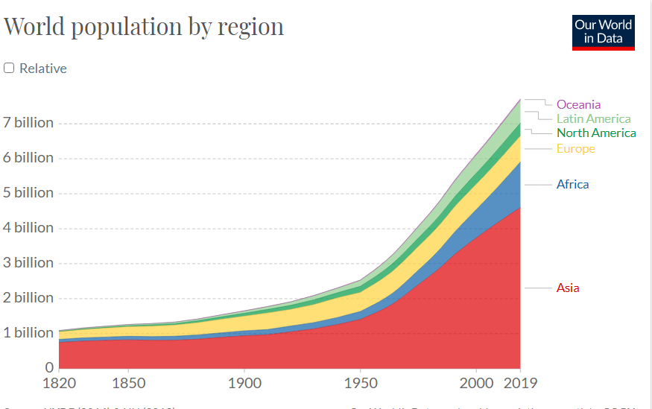 Fig 1

industrialization

Not surprisingly, this did not come without generating changes, societal as well as material. Societal changes were taken care of by society, by whatever institutions and governments were in place not considered as problems.

It is some of the material changes that became problems for which society was not prepared. The situation became of concern, at first to members of industrial and academic communities, later brought to the general public’s attention by the news as well as other publications. Most significant in that respect were reports of studies conducted by a mostly academic international community known as the Club de Rome (to which I had the pleasure to participate), in particular the publication in 1972 a book suggestively entitled The Limits to Growth. The gist of what it said was in the form of a warning :
…. that if the increase in human presence, the increase in population and industry were not stemmed, were not reversed, then in the near future, a few decades, major problems would affect society and life on Earth.

That this generated a worldwide interest at the time was illustrated by the fact that the book was translated in 30 languages, ended up with 30 million copies being printed. Journals and magazines (including Playboy !) published articles or commentaries about it. The New York Times Review of Books had to devote a special issue to this abundant literature (February 1972).

What the Club of Rome and other studies were proposing was in fact that people reduce their standard of living, have fewer children, asking business and industries to reduce the volume of their productivity. This was not well taken, asking people as well as leaders of the industrial-business establishment to abandon their views of the future, have ‘reduce’ replace ‘grow’ that was the general view at the time. ‘Reduce’ is not part of human nature, it is felt as a failure. As a consequence little took place, the fact of not talking about it being an escape from facing the problem. Talking about the population’s size problem became a taboo that exists to this day, not much different from what psychologists call motivated forgetting for individuals.

Though it is not the case that the problem was entirely ignored by all. The United Nations had initiated a series of conferences called World Summits on Sustainable Development, one every 10 years beginning with Stockholm 1992 to be followed by Johannesburg 2002 . A significant expression of reality came when W.Lutz and M.Shah, two research scientists with IIASA (a reputed international research center and think tank located in Laxenburg, Austria) wrote before the conference a letter to the journal Nature. We read in its first paragraph: “Population as a key compound of sustainable development should figure prominently on the Johannesburg agenda. Yet, after four preparatory meetings for Johannesburg 2002, the topic is still absent”.

The letter was published by Nature (22 August 2002), together with the journal devoting its own Editorial repeating the same message. But in the end the subject of population was not included in the agenda of the conference. Nor was it included in the agenda of Rio 2012, the next conference in the series, in spite of the fact that the world’s population had grown from about 5.5 to over 7 billion since the Rio 1992 conference, the world global GDP from $24 to $71 trillion.

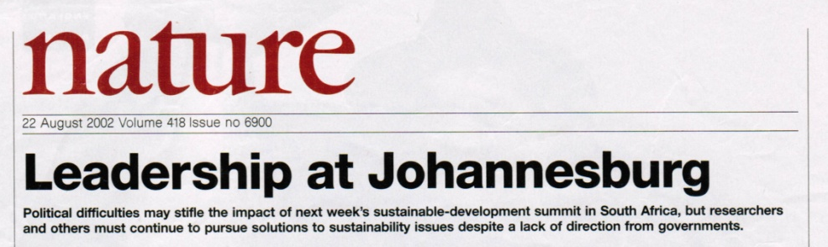 fig 2

With about 50,000 participants including state delegations and heads of state, the agenda of Johannesburg 2002 ended up consisting of mostly papers devoted to proposed solutions to immediate problems - like hard living conditions and diseases in developing countries, pollution, exhaustion of water resources, etc…. Working on these problems is what “sustainability” in the title of these conferences had come to mean, with nothing said about curbing the rise of population and industry. So, they have continued to grow.

growth

Growth is described in a number of ways, many in a flattering manner. But concerning the impact on the physical environment, what counts are those factors that decribe our influence as what may be called ‘the human presence footprint’. Significantly, the quantity that describes this is energy. The total amount of energy we consume depends on industry, itself influenced by population size. It is the case that the increase in our numbers, in our living the way we do today are made possible by our use of energy. That most of that energy comes from fossil fuels may be seen in fig.3, showing not only today’s global consumption but also how this has evolved since the beginning of the industrial revolution.

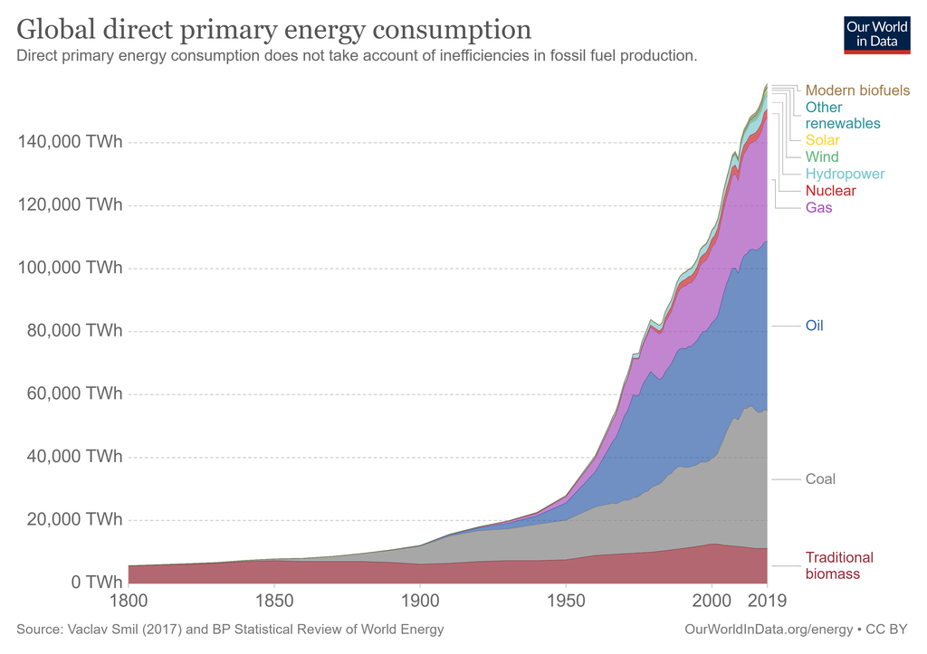 fig 3

Important to note is that this shows little inflence by those events labeled as “the news”, that include politics, wars, economics, all dutifully reported by the media and that form the essence of public opinion. Which reflects the two ways to look at the evolution of our world, the short term (largely that which forms the general public opinion), then the long term, illustrated by the above.

global warming and attempts to stem its growth

A major problem predicted in the 1970’s by the Club of Rome was in the rise of pollution brought about by industry without details as to what it would be, but enough so to become harmful by the end of the first quarter of the 21st century (where we are today). It turned out that this is indeed happening, with pollution resulting from the burning of fossil fuels with residues in the form of gases, -- mostly CO2 accumulating in the upper atmosphere and creating global warming. That global industrialization holds an important responsibility in this is confirmed by fig.4 that shows its increase with that of the gobal population, and that it is the industrialized countries that emit most of the . CO2.

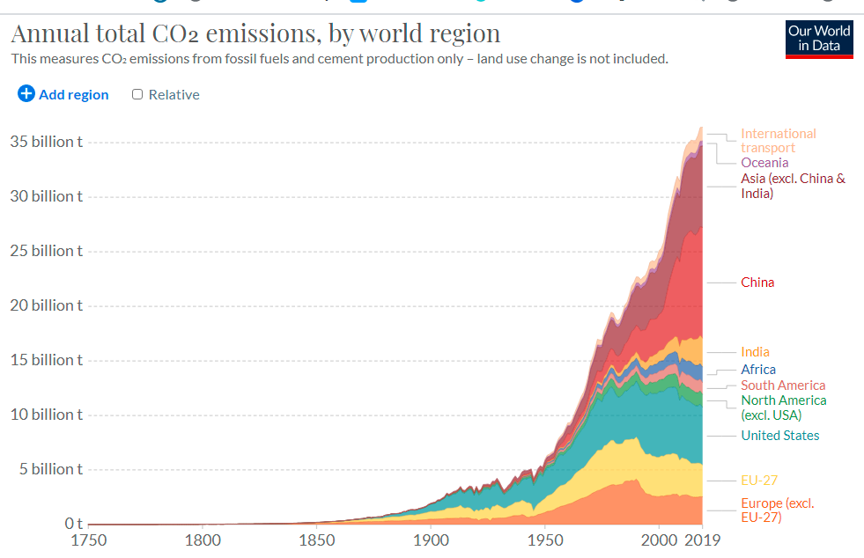 fig 4

How this results in global warming is that there are two main factors that determine the Earth temperature,. First is heat coming in from the Sun by radiation, - then heat radiated back to space by the Earth , It is the fact that the latter has become impeded by a greenhouse effect created by those residue gases in the upper atmosphere that results in global warming.
The adverse consequences of global warming were realized and have been addressed for some time. . The United Nations began organizing yearly Climate Change Conferences, referred to as COP, the first in Berlin in 1995. They have grown exponentially in size — from small working sessions into being amongst the largest worldwide conferences. Among them was COP3, held in Kyoto, Japan, that gave life to the Kyoto Protocol in 1997, the first agreement to bind industrialized countries to reduce emissions within given limits..

The importance given to COP21, the Paris 2015 Climate Change Conference resulted from the fact that this time delegates were no longer those who impose limits and reductions to countries, but governments were asked to present their CO2 reduction proposals, having the potential to bring important economic consequences, The resulting so called Paris Agreement came in the form of ‘action types’ by order of importance : emission reductions, carbon price, bonds insurance, renewable energy , energy efficiency and resource consumption (fig.5).

. .
Fig 5
’Action types’ of the Paris 2015 Agreement.

In spite of its predominant importance, reducing human population, human footprint on Earth is ignored.

The original objective of the 2015 Paris Agreement was to combat global warming, much of it by reducing the amount of greenhouse gases, CO2 in particular, emitted by humans on Earth. What figs.1 and 3 tells us is that there are realistically two ways in which this could be achieved, first by reducing the size of our population, the amount of energy it consumes, second by increasing the amount of non-carbon, renewable sources of energy. The relationship with global population is confirmed by noting the similarity between fig. 1 (population) and fig 4 (CO2). Yet, ‘ population’ was not included as an ‘action type’ , a repeat of the Johannesburg 2002 story.

In the end, the main thing that the 2015 Paris Agreement did ask is that we reduce our use of fossil fuels that are largely responsible for the emission of greenhouse gases. But the absence of a parallel reduction in the world’s population means little overall reduction in our demand for energy. Some ninety percents of today’s energy comes from the use of fossil fuels, reducing using them leaves a gap asking that renewables take over, that their contribution be increased.

renewables
Where we stand regarding renewables may be seen as the top right corner of in fig.3. Wind and hydropower considered as renewables are in fact solar energy that creates air and water movements on Earth.

Then nuclear energy, energy that is released by reactions at the atomic level, the same in fact as those taking place inside of the Sun. By contrast with popular belief, the
contribution of nuclear power to today’s world’s energy consumption is no more than a few percent of the total, And looking at how this has evolved over the past decades leaves one with little expectation that this will change by much. Nuclear power we use is so far obtained by nuclear fission. We hear of nuclear fusion, of the huge amounts of energy it might generate. But feasibility is not at all established. That “it will be established in the next 20 years” is repeated without change for since the 1970’s or so (as of late inevitably with a smile). Latest is the ITER truly international project going on in Cadarache, France. Even if feasibility were established, the enormously sophisticated equipment and technically educated personnel needed, the logistics and politics of distributing energy from large generation points to far away , some undeveloped regions on Earth are fraught with problems, some realistically intractable.

Numbers

Too much ignored
comes the question of global numbers. In that respect, fig.3 (actual data) says that replacing fossil fuels by half or so (a credible guess as to what is needed to have a sensible effect on global warming) would require that the amount of energy from renewables be on the order of ten or more times than what it is today. And that this be accomplished in the next few decades.

This does not agree with what the experience of the past few decades (fig.3 ) tells us. This actual data shows how little total increase in the production of renewables, how small its rate of increase from year to year have been.. This is reality, it includes thousands of factors that include science (what is theoretically feasible ?) , development (what facilities, what scientific , technical and other appropriately prepared personnel, manpower exist ? ), political/economic (which countries will agree to stop/start doing what, given theoir own lnterest and problems).

Some is feasible, some is not. This take time.
Some make it believe that it is just money... not so.

The next one or two centuries

Mention should be made of another problem that is to come in the next one or two centuries : the amount of available fossil fuels is finite, shall not last one or two
centuries.. Fig.6 shows an estimate of how this is to take place. It may well be that this does not include fracking, deep sea drilling and the like that may change some of those numbers but, as was said decades ago in the same context by Charles Galton Darwin : ‘for the present purpose it does not matter if these are under-estimates; they could be doubled or trebled and still not affect the argument’

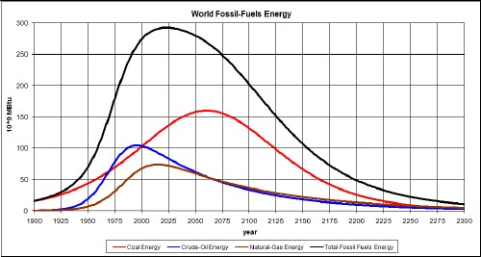 fig 6

The search to find sources of energy other than fossil fuels came with the fight against global warming’. But “renewable” energy shall be needed in amounts not only equal to today’s consumption to allow life on Earth to continue with the luxuries provided by today’s “industrial” world, but more coming with the continued increase of population.

EPILOGUE the energy buble.

Not sufficiently realized is that the amount of energy in the universe is a set quantity. It exists in many forms (including mass) , it may change from one form to another but with a total that is essentially unchanged.

Life on Earth started using solar energy, it evolved from simple organisms to the great variety of species we know. Important to note is the separation between flora (plants) and fauna (animals). It is the former, plants that capture solar energy, then serve in one form or other as food for the fauna, animal species including humans.

This has been going on for millennia, solar energy taken by plants (flora) , some of it used directly or indirectly by animals (fauna) , some accumulating in the
underground as solid, liquid or gaseous matter rich in carbon, today’s fossil fuels.

It is the case, as illustrated by the above figures, that size the human civilization on Eartht has at all times been directly related to the amount of energy consumed

We, were limited in the pre industrial era limited to the energy of solar light. Then , in the period we live in and that shall last no more that a few centuries, also tapping into the energy of fossil fuels, allowing our civilzation to grow in size, as well as living more expensively.

D. Meadows et al. The Limits to Growth Potomac – Universe Book (1972),
in The Next Million Years, (1953, Doubleday, New York) Charles Galton Darwin, a grandson of Charles Darwin.

