 IMACS 2021


LIFE ON EARTH, past and future
Robert Vichnevetsky
Princeton, NJ. rvichnevetsky@aol.com

In a few centuries from now historians will talk of the pre-fossil fuels era that ended with the 18th century, of the post-fossil fuels era they shall be living in at the time, and of a few in-between centuries that may be called “the fossil fuels era”, that we live in today, that shall remain most significant for having brought irreversible changes to life on Earth, and not for the best.

Life on Earth is in a period of significant change, change that started with the discovery, often illustrated by James Watt’s steam engine (1795), that energy in the form of mechanical power could be derived from thermal energy, that obtained by burning wood or coal at first, oil and natural gas later on, those other than wood referred to as fossil fuels.
Before this, and other than for windmills, watermills and the like, the only available sources of mechanical power were muscular, from humans or animals. It turned out that the amount of power available from fossil fuels was by orders of magnitude greater than what had been available so far. This was quickly taken advantage of, at first in countries of the North Atlantic world, leading to what has come to be known as the industrial revolution.
A significant contribution to these changes ( I consider it as the most significant) was in the development of new means of transportation, in capacity much larger than what had been available before. Populations had been limited in size and geographic distribution by the need for all to live near places where food was produced. These limitations disappeared with railroads, steamships and other means of transportation bringing food from far away, bringing people to regions that had so far been inhabitable and resulting in an increase in the world’s population, an increase still going on today ( fig.1). We are in numbers today close to ten times as many as we were in James Watt’s days, much in a society converted by necessity from rural to mostly urban living.

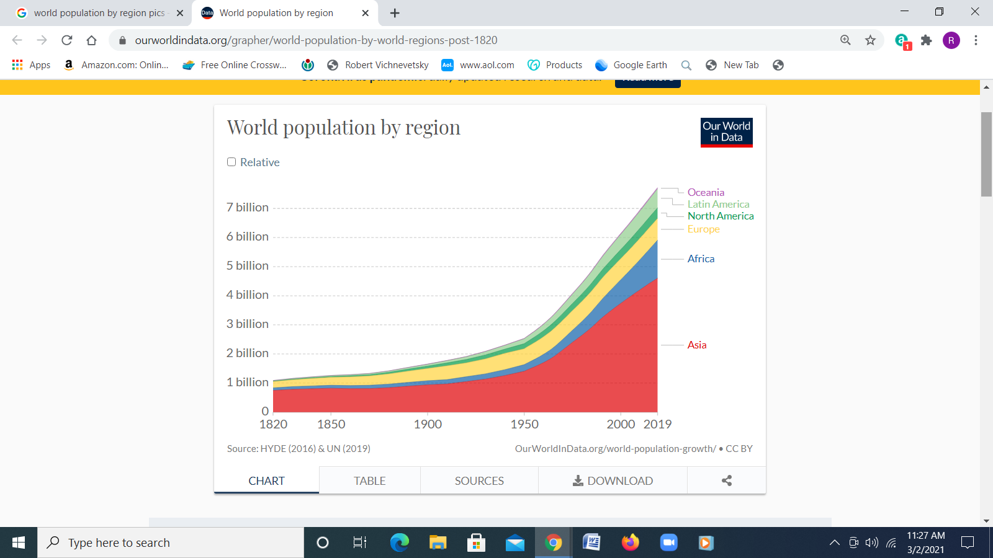 Fig 1

industrialization
Population growth and urbanization demanded new products, leading to the development of industry. Iron and steel as a significant part thereof started growing in the 1800’s, a few decades after James Watt’s steam engine and had, before the end of the century, led to such things as locomotives, railways. a network of new modes of transportation, including to and in parts of the then undeveloped world. This did not come without generating major changes, societal as well as material. Societal changes coming with more urbanization and interdependences were not seen as something new, they were managed by the institutions and governments already in place. But it is material changes that led to problems for which, other than for being aware of a few philosophers like Malthus and the like, society was not prepared. Unnoted at first, it is in the late 20th century that the presence of material problems was realized , that they became of concern, initially to members of learned, academic communities and brought to the general public’s attention by the news and other publications. Most significant in that respect were studies conducted by an international, mostly academic community known as the Club de Rome (to which I had the pleasure to participate), in particular the publication in 1972 of a book suggestively entitled The Limits to Growth. The gist of what it said was in the form of a warning

…. that if the increase in human presence, the increase in population and industry were not stemmed, reversed, then in the near future, a few decades, major problems would affect society and life on Earth.

That this generated a worldwide attention at the time was illustrated by the fact that the
book was translated in 30 languages, ended up with 30 million copies printed. Journals and magazines (including Playboy !) published articles and commentaries about it. The New York Times Review of Books had to devote a special issue to this abundant literature (April 1972).

What the Club of Rome and other studies were recommending was indirectly that people reduce their standard of living, have fewer children, asking business and industries to reduce their size, their productivity. This was asking people as well as leaders of the industrial-business establishment to change their views of the future, have ‘less’ replace ‘more’ that was the trend at the time. But going for ‘less’ is not part of human nature, it was not well taken and therefore little took place. Talking about the population’s growing size as a problem became a taboo, a taboo that exists to this day, in fact not much different from what psychologists call motivated forgetting for individuals.
Though it is not that the problem was ignored by all. The United Nations had initiated a series of conferences called World Summits on Sustainable Development, one every 10 years beginning with Stockholm 1992 to be followed by Johannesburg 2002 . A significant expression of reality came when W.Lutz and M.Shah, two research scientists with IIASA (a reputed international research center - think tank located in Laxenburg, Austria) wrote a letter to the journal Nature before the conference . We read in its first paragraph : .“Population as a key compound of sustainable development should figure prominently on the Johannesburg agenda. Yet, after four preparatory meetings for Johannesburg 2002, the topic is still absent”. The letter was published by Nature (22 August 2002), together with the journal devoting its own Editorial repeating the same message. But in the end the subject of population was not included in the agenda of the conference. Nor was it included in the agenda of Rio 2012, the next conference in the series, in spite of the fact that the world’s population had grown from about 5.5 to over 7 billion since the Rio 1992 conference, the world’s global GDP from $24 to $71 trillion.

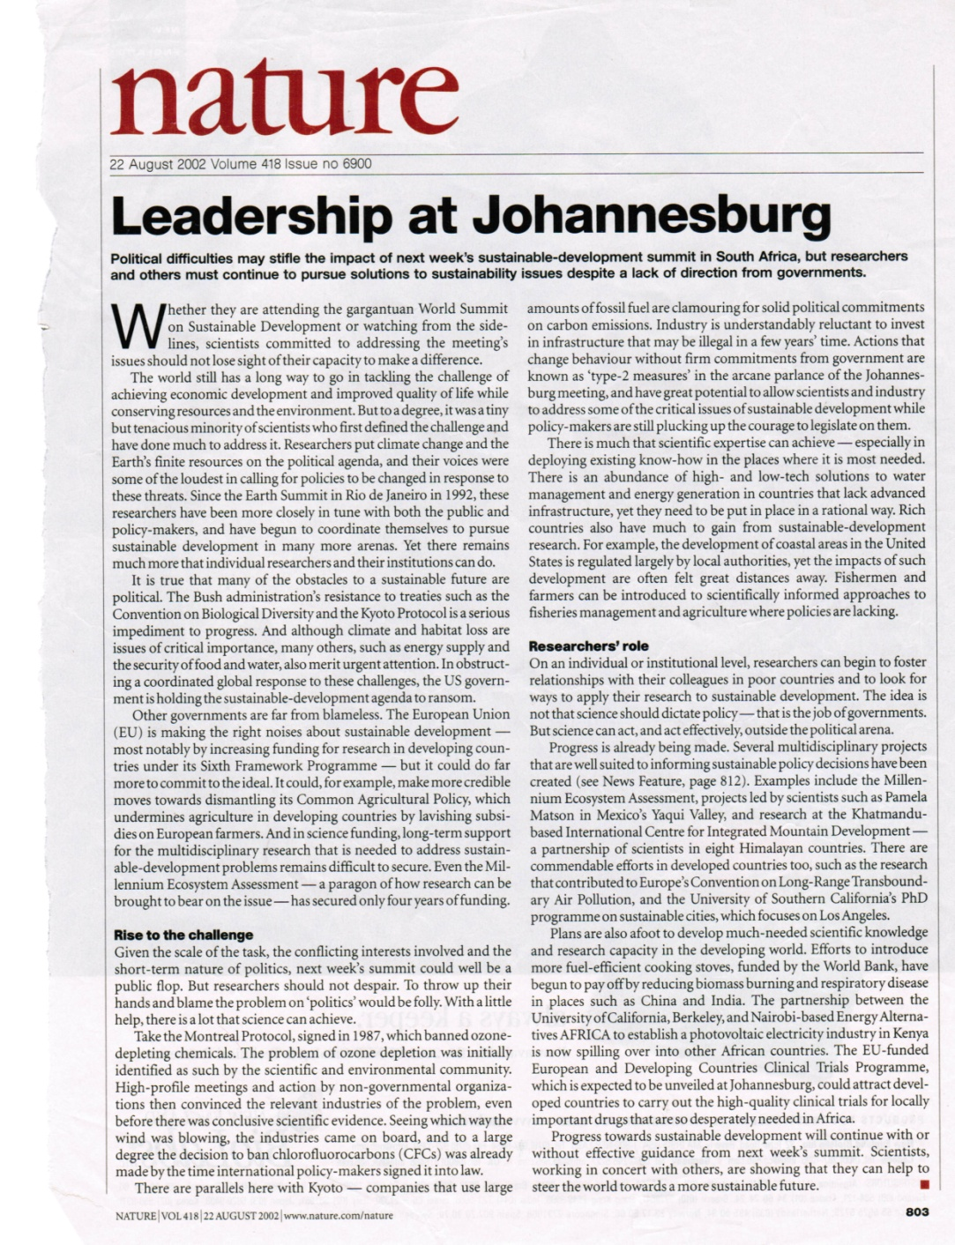 fig.2

With about 50,000 participants including state delegations and heads of state, the agenda of Johannesburg 2002 ended up consisting of mostly papers devoted to proposed solutions to immediate problems like hard living conditions and diseases in developing countries, pollution, regionally not sufficiently accessible transportation, etc…. Working on these problems is what “sustainability” in the title of these conferences had come to mean, with nothing said about curbing the rise in population.

consuming energy
I like for us to take a step back and be reminded that having been brought to this situation was the result of having discovered a significant source of usable energy, that contained in fossil fuels, having discovered that using that energy opened the door to a whole set of new possibilities like mechanized agriculture and transportation leading to an exponential growth in our numbers. Also leading to, at first for some, later to potentially all on Earth to a spectacular improvement in what is called the quality of life. This continues to this day with larger populations coming with larger consumption of energy. The two, energy consumption and population size are fundamentally related, a relationship coming inevitably with difficulties and problems, a situation in which energy has and will continue be the most important factor. Its most visible participation is in the presence of industrial facilities seen all over the world.

So, population and industry ‘s size continued to grow, with growth described by the media in a number of ways, most in flattering terms describing novelties in living conditions with no mention of the undesirable consequences, one of them the impact on the physical environment. Impact on the environment turns out to be a most important factor counting for the long term, the consequence of what is sometimes called the ‘ human footprint’. Much of it is measurable by the amount of energy we consume. Fig.3 shows today’s global consumption of energy as well as how this has evolved since the beginning of the industrial revolution, and what part of it consists of fossil fuels.

.

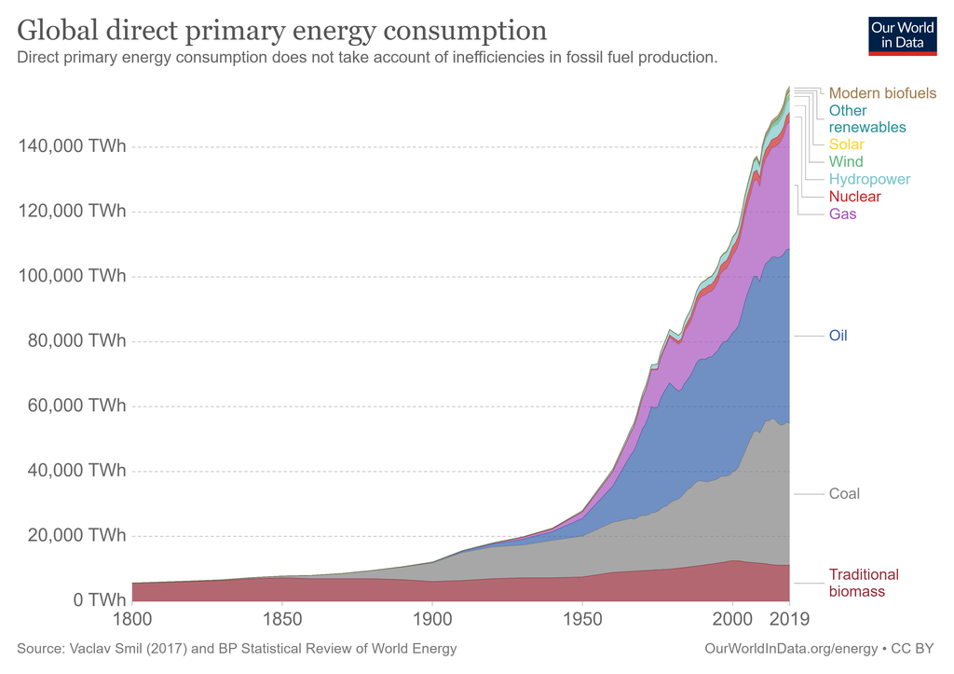 fig 3

global warming
One of the problems predicted in the 1970’s in the Club of Rome studies was in the rise of pollution. But other than for predicting that it would become harmful by the first quarter of the 21st century (where we are today), giving no details as to what that pollution would consist of. It turned out that this is indeed happening, with pollution in the form of gases, residues from the burning of fossil fuels, mostly CO2, accumulating in the upper atmosphere. How this results in global warming is that there are two factors that influence the Earth’s temperature. First is heat coming in from the Sun by radiation, then heat radiated out back to space by the Earth . It is that cooling resulting from the latter becoming impeded by the greenhouse effect created by those residue gases in the upper atmosphere that results in global warming. That industrialization holds an important responsibility in this process is confirmed by fig.4 that shows that it is the most industrialized regions of the world (Europe, North America, China) that emit most of the CO2.

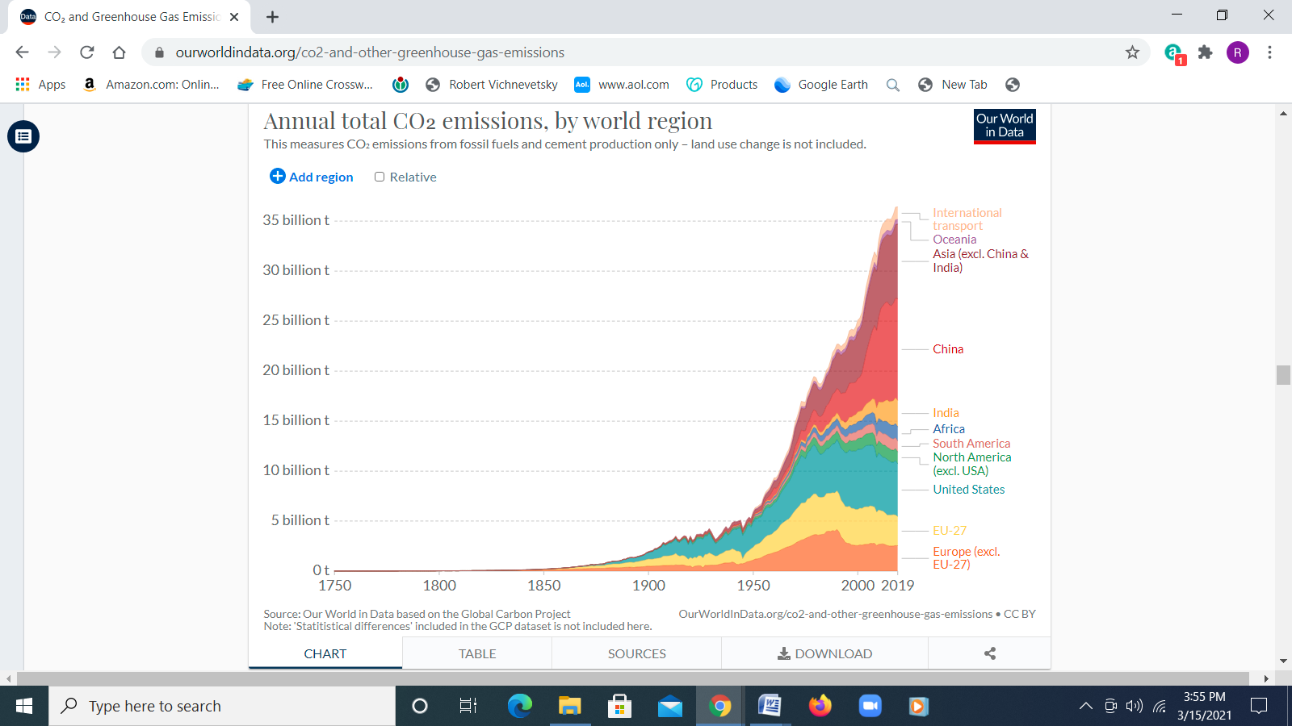 fig 4

The adverse consequences of global warming have been realized and addressed for some time. The United Nations began organizing yearly Climate Change Conferences referred to as COP, the first in Berlin in 1995. They have grown exponentially in size from small working sessions into being amongst the largest worldwide conferences. Among them was COP3, held in Kyoto Japan, that gave life to the Kyoto Protocol in 1997, the first agreement to bind industrialized countries to reduce emissions within given limits.
The importance given to COP21, also known as the Paris 2015 Climate Change Conference resulted from the fact that this time delegates were no longer those who impose limits and reductions to countries, but governments were asked to present their CO2 reduction proposals, having the potential of bringing important economic consequences .


fig 5
Action types of the Paris-2015 Agreement.

In spite of its predominant importance, reducing human population, human footprint on Earth is ignored.

The resulting so called Paris Agreement came in the form of , by order of importance

emission reductions, carbon price, bonds insurance,
renewable energy, energy efficiency, resource consumption
.The stated objective of the 2015 Paris Agreement was indeed addressed - mostly by asking for a reduction in the emission of greenhouse gases, in particular CO2 emitted as a result of human presence on Earth. But what figs. 1, 3 and 4 tell us is that there are realistically two ways in which emission reduction could be achieved,
- by increasing the amount of non-carbon, renewable sources of energy.
- more so by reducing the size of our population leading to lesser amounts
of energy consumed. The relationship of CO2 emission with energy consuming population size is indeed confirmed by noting the similarity between fig.1 (population) and fig.4 (CO2).

Yet, population was not included as an ‘action type’ in the Paris 2015 Agreement (fig.5 ), a repeat of the Johannesburg 2002 story. In the end, the main thing that the 2015 Paris Agreement did ask is for a reduction in our use of fossil fuels. ut the absence of asking for a parallel reduction in the world’s population means little reduction in the demand for energy consumed. Close to ninety percents of today’s energy we consume comes from fossil fuels, reducing the latter leaves a gap asking that renewables take over, that the amount of their contribution be increased. And there is a difference between technical feasibility, and feasibility in the amounts required,
... technical feasibility is well established, ...but in the amounts required not so well !!!

renewables
What has been achieved so far in the pursuit of renewable energy (meaning energy that does not come from fossil fuels) may be seen as the top right corner of fig.3. It is not impressive.
Wind and hydropower considered as renewables are solar energy - that creates air and water movements on Earth. Then nuclear energy, energy that is released by reactions at the atomic level, the same as what takes place inside of the Sun. By contrast with popular belief, fig.3 says that today’s contribution of nuclear power to the world’s energy consumption is no more than a few percent of the total (more so, as some do, by considering the generation of electricity alone, but that is not the global picture and does not count). And looking at how little this number has increased over the past few decades leaves one with little expectation that it will change by much. In fact, France decided recently to reduce their production of electricity from nuclear power plants, something they were the leaders of, to gradually eliminate those plants. And so did Germany. Nuclear power we use is so far obtained by nuclear fission. We hear of nuclear fusion, of the huge amounts of energy it might generate. But feasibility is not at all established, the sentence “feasibility shall be established in 20 years or so” has been repeated without change since the 1970’s (as of late with a smile). Latest is the large ITER international project going on in Cadarache, France. Even if feasibility were established, the enormously sophisticated equipment and technically educated personnel needed, the logistics and politics of distributing energy from large generation points to far away, to some developing regions on Earth are fraught with problems, some realistically intractable.

Fig.3 that depicts reality says that replacing the energy from fossil fuels by half or so (a credible guess as to what would be needed to have a sensible effect on global warming) and not reducing our population size (whence our consumption of energy) would require that energy from renewables be somewhere 5 or 10 times what it is today. And that this be accomplished in the next few decades. Big question is as to whether that is feasible.
What it asks does not agree with our experience of the past.

differences
Too little mentioned are ( the difference between what researchers in labs and think tanks say, and what is said by those in industry who actually have to produce measurable results, particularly important when it comes to numbers. In that respect, fig.3 - that depicts reality - says that replacing fossil fuels by half or so, ( a credible guess as to what would be needed to have a sensible effect on global warming) and not reducing our population size (whence our consumption of energy) would require that energy from renewables be somewhere between 5 or 10 times what it is today. And that this be accomplished in the next few decades.

Which does not agree with what our experience says. What fig.3 shows is how little the year to year increase in the production of renewables have been achieved, what the total increase over the past few decades, has been. Not that much.
Those are real numbers, they include the mixed contribution of thousands of factors that come from
-- science (what is theoretically feasible) ,
-- development (what facilities, what scientific , technical
and other appropriately prepared personnel, manpower does exist...),
-- politics and economic (which countries have agreed to stop / start doing what,
given their own problems and interests ).
But the three communities this represents (scientists, engineers, economists) hardly work together, they do not speak the same language.

the further away future
Of no concern today , but will in a few generations from ours is a significant problem that is inevitably coming : the amount of existing fossil fuels is finite, shall not last one or two more centuries. Fig.6 shows an estimate of how this is to take place. It may well be that this does not include fracking and the like that may change the numbers, but as was said decades ago in the same context by Charles Galton Darwin : ‘for the present purpose it does not matter if these are under-estimates; they could be doubled or trebled and still not affect the argument’

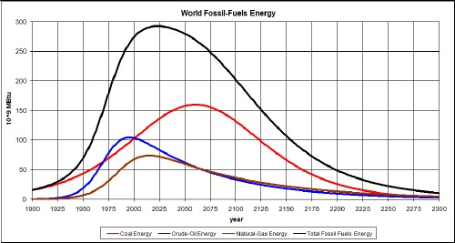 fig 6

The search for sources of energy other than fossil (the so called renewables) came first with the intent to combat global warming. But after the exhaustion of fossil fuels, renewable energy shall be essential, needed in amounts comparable to today’s total world energy consumption. Unless our capacity to generate renewable energy becomes much better than what it has been in the past few decades, it looks like a reduction in size of the human population shall, in one or two centuries from now, be almost inevitable. This may not happen by design (like the ‘two children’ legislation or ‘increasing education’ ), it shall include what we see is already taking place, starvation and genocide that are attributed to conflicts and wars, conflicts and wars that are in fact generated by stressed populations whose numbers have increased beyond what means of subsistence can be generated locally, beyond how much can come from elsewhere. Today’s Yemen whose population went from 6.4 to 30.7 million between 1960 and 2021, and about 90 percent of the food they consume having to be imported as a typical example. .. and there are many more.
energy
It is most interesting to review what is happening from a broader perspective, that of energy. It is energy that brought the industrial revolution, radical changes to the way we live. It is energy that is behind population, economic, political developments of most of the world. It exists in many forms, may change from one to another but with a total , universal amount that is essentially unchanged.
Life cannot exist without energy. Life started on Earth a few trillion years ago using energy coming from the Sun by radiation, it evolved from simple organisms to a great variety of species, only some we know today. Interesting is the distinction between flora (plants) and fauna (animals). It is flora that captures solar energy, uses it by combining elements to produce biomass that serves directly or indirectly as food for the fauna, animal species to which we belong. Some biomass that had not been otherwise used had , for millennia. accumulated fin our underground where it resides as matter - rich in carbon - containing solar energy from the past that we use today as fossil fuels.
Something important did happen when were discovered, some two and a half centuries ago, ways to convert heat to mechanical power, thermal energy to mechanical energy, We obtained thermal energy, lots of it by burning fossil fuels, leading to a significant development of machinery, including means of transportation that did not exist before. We had in pre-industrial times been limited in population size by how much of the energy coming from the Sun we could use by way of plants growing at the time, the logistics thereof forcing us to live nearby. These limitations were removed with transportation bringing food from far away at the expense of tapping into more of the energy of fossil fuels, allowing us not only to grow in size but also to lead a more expensive often environmentally damaging life.
But this shall not last more than a few more centuries, we are running out of fossil energy. Our life shall depend on what technology, what machinery we may develop to capture more solar energy. That this, in combination with other renewables (nuclear and geothermal) shall have the capacity to generate energy in amounts on the order of what we use today and to distribute it where needed on Earth are questionable.
In all we - that live in that golden “fossil fuels era” - shall leave for those in not that many generations from now a world, a civilization built to function with, to depend on lots of energy ..... energy that shall be much harder to come by than it is today - we get, have gotten most of it by not much more than having to dig holes in the ground. We leave a world environmentally damaged by our excessive exploitation of natural resources, a world where we have already managed (with more of it to come) to eliminate many of the (other) animal species that were still thriving at the onset of the industrial revolution.

Robert Vichnevetsky was professor, now emeritus (Princeton, Rutgers, Computer Science and Aerospace Engineering). He was in industry prior to his academic career, in the 1950’s with EAI’s European Computer and Center in Brussels, participating in every segment of the recovering European industry, including the development of nuclear power in France and Great Britain. He came to Princeton in the 1960’s as director of EAI’s Computer and Research Center, working with NOAA and NASA’s Space program. He has throughout most of his career been involved with the development of the international network of professional scientific societies that emerged after the war, was in that respect part of a working committee with UNESCO- Paris and for a number of years president of IMACS, the International Association for Mathematics and Computers in Simulation that organizes international conferences and publishes scientific journals (Elsevier and World Scientific). He was in 2005 inducted in the International Hall of Fame in Engineering, Science and Technology

D. Meadows et al. The Limits to Growth Potomac – Universe Book (1972),
in The Next Million Years, (1953, Doubleday, New York) Charles Galton Darwin, a grandson of Charles Darwin.

